The application is entirely designed keeping in mind ReactJS best practices. I have used the below libraries for application development :

1. React Hooks
2. React Context
3. Tailwind CSS
4. React Date Picker

The application on start looks like below

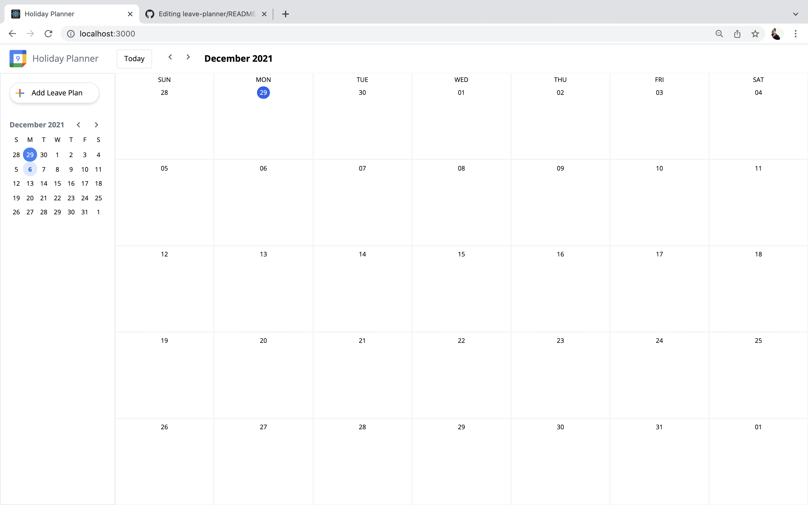

On clicking any date , a modal is designed to open as below :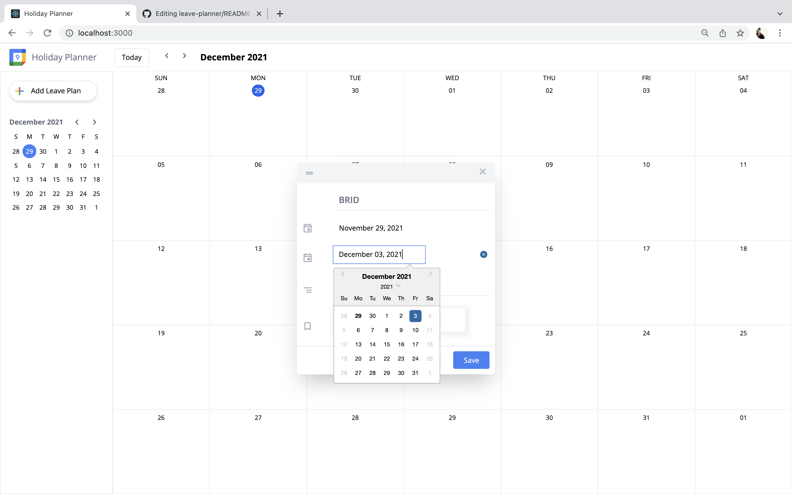

There are leave options enabled inside code to pick up the leave type. Further design plans to make it look more attractive is in progress:

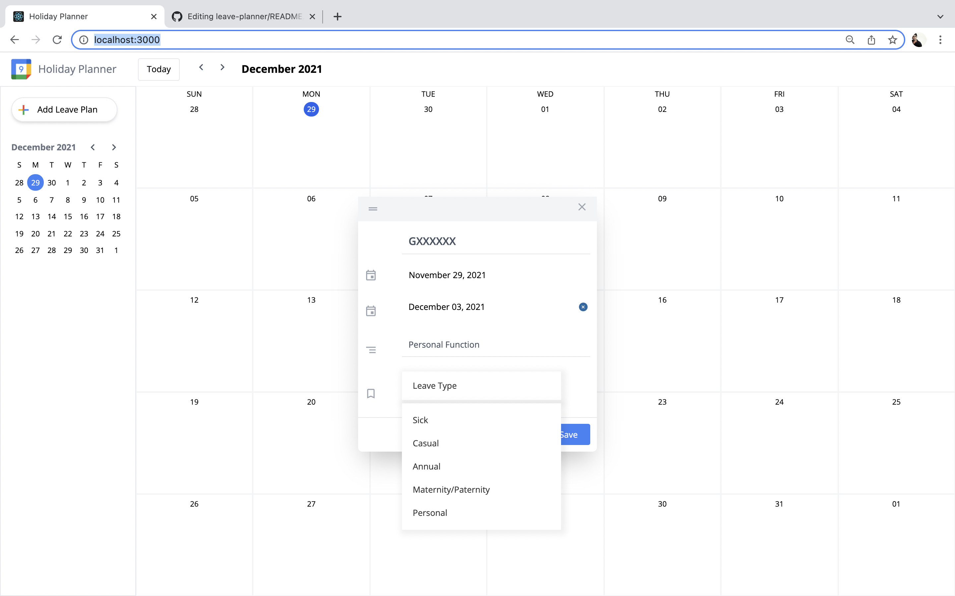

On clicking the save after entering particulars, you should be seeing like as below:

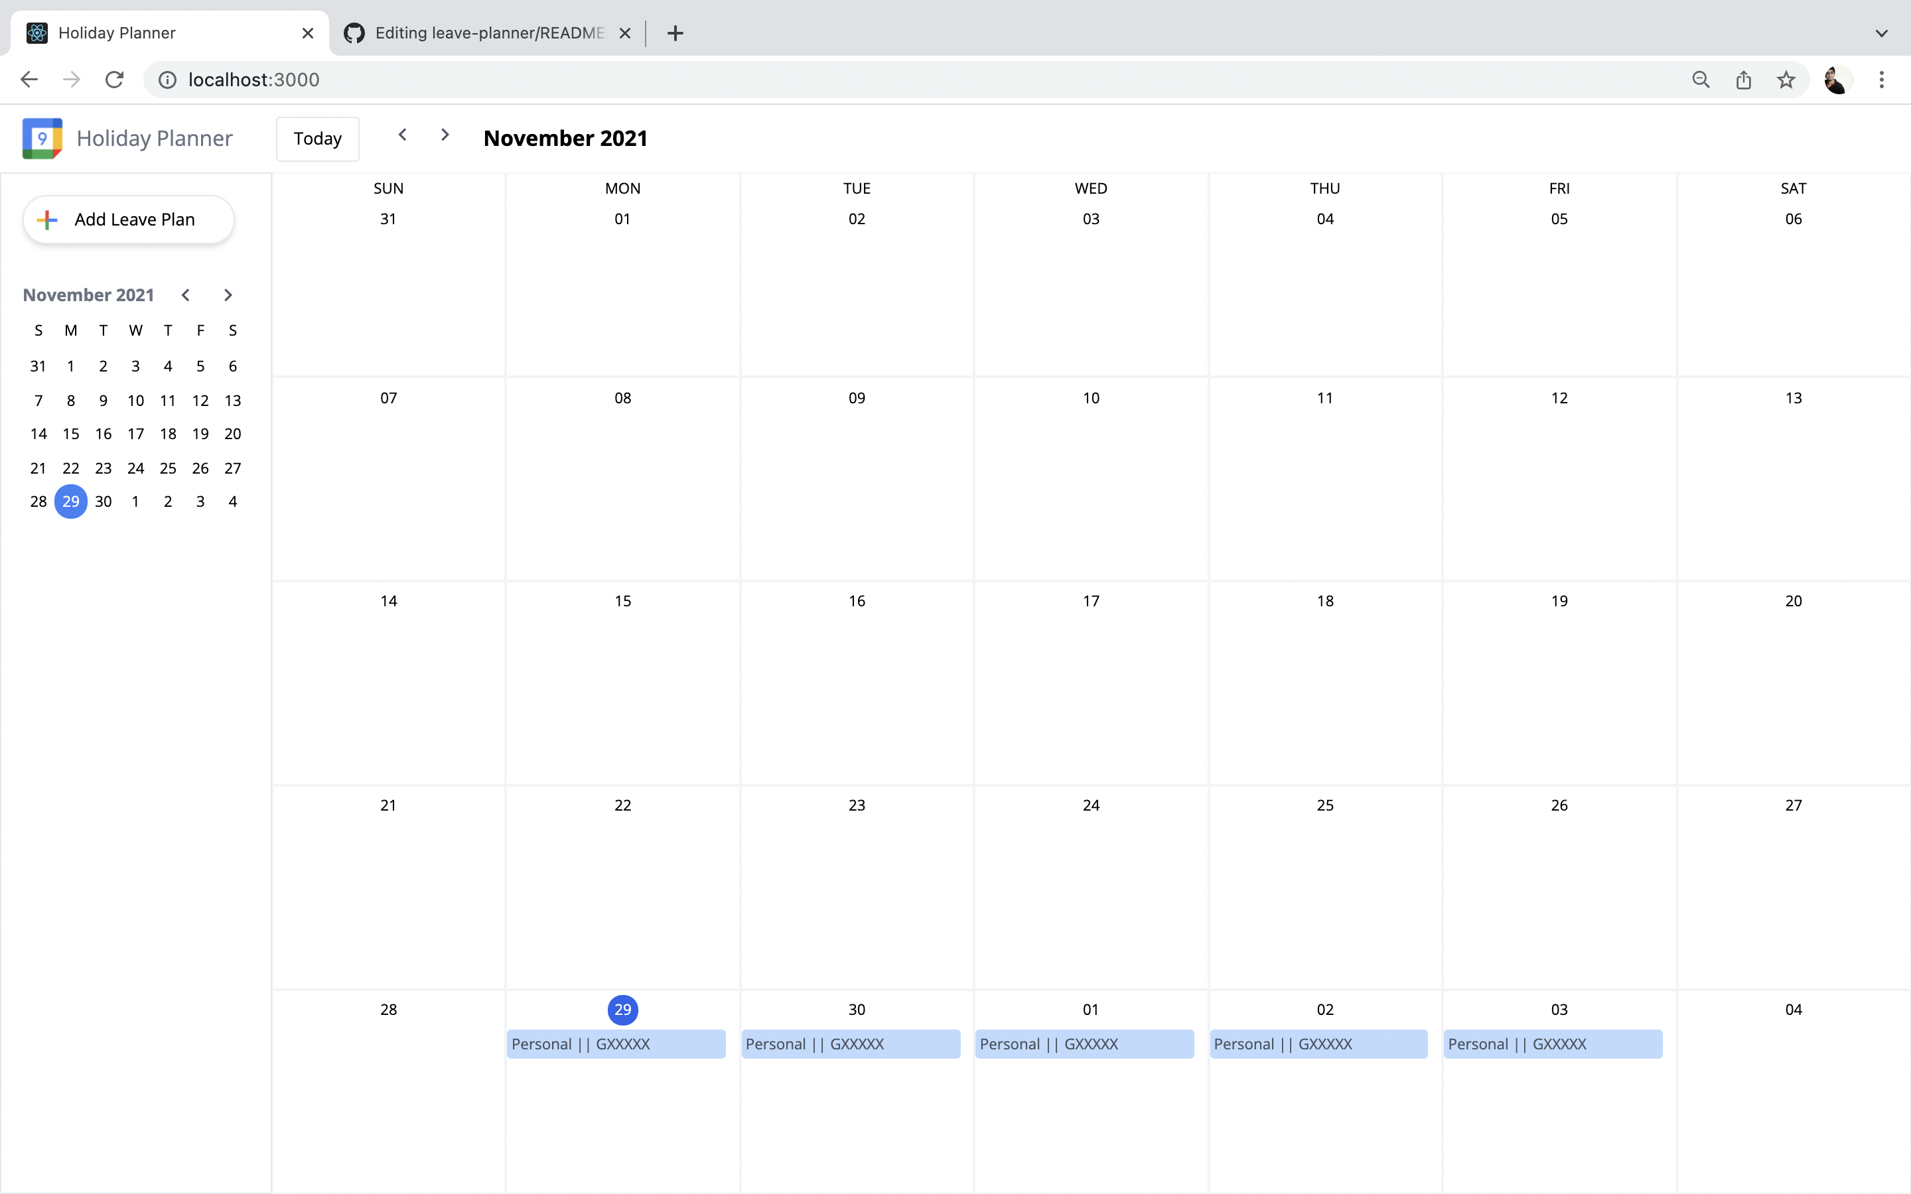

If you see on the right corner and compare the previous modal, a difference you should be seeing is the delete icon. This enables you to delete the entire event if you wish. Currently, events that span across multiple days use same event id so they get deleted on click of any one of them. If individual day events needs to be cancelled, we can design from that angle.

Also, if you update any particular, it updates the fields as required. Different color legends are given - here personal is blue. For sick it is red and for some other fields it is indigo.

